Just eat it: Vocabulary

- Match the words to the correct pictures.

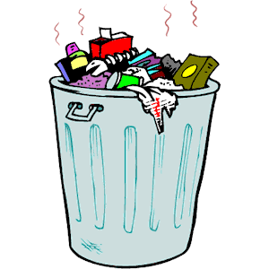
Soil Dumpster Trashcan

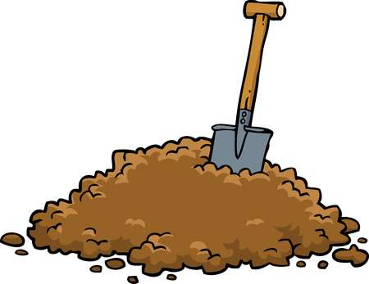
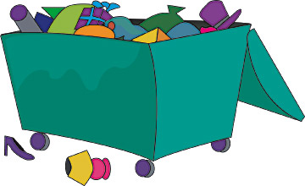

- Match the words to their definitions.

- Sustainable agriculture
- (To) harvest
- To grow
- To be out of
- Food bank
- Policy
- Surplus
- Greenhouse gases
- Climate change
- Donated food

- Gases causing greenhouse effect, such as carbon dioxide or methane
- More than what is needed or used
- To have no remaining
- The season (or the process) when the vegetables or fruit are gathered
- Enviromentally friendly farming methods that try to keep an ecological balance
- General rules that people should follow
- A center that collects food and distributes it to the needy people
- Food given someone who needs it
- A long-term process associated with an increase in the average atmospheric temperature
- To inscrease in size or substance

