**Meatrix**

1. **Can you describe the following pictures?**

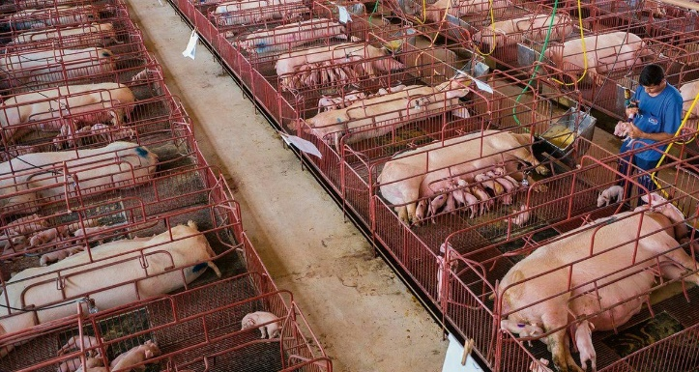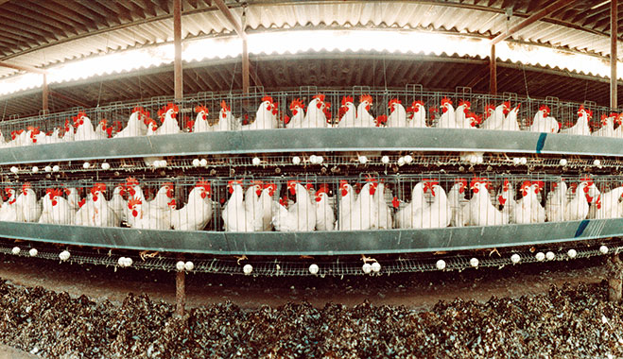

1. **What do you feel after watching the film? Circle your emotion and speak about it.**

